Travel Agency

Assignment documentation

Student: Csatlos-Koncz Andrei

**Group: 30432**

Contents

1 Requirements Analysis 3

1.1 Assignment Specification 3

1.2 Functional Requirements 3

# Requirements Analysis

## Assignment Specification

This is a JavaFX with Hibernate application desired for booking a vacation. The application has two users (travelling agent and customer) which must provide a username and a password in order to login in the application. All the data is stored in a database implemented with MySQL. There are three tables in the database: users, destinations and vacation packages.

## Functional Requirements

* The Travelling Agency should be able to:
  + 1. add vacation destination
  + 2. add vacation packages for a specific destination
  + a. should contain information: name, price, period, extra details, number
  + of people that can book the vacation
  + 3. edit an existing vacation package
  + 4. delete an existing vacation package
  + 5. view all its listed vacation packages (with status: BOOKED, NOT_BOOKED,
  + IN_PROGRESS)
  + 6. delete vacation destination
* The Regular User should be able to:
  + 1. register on the platform using some credentials (username/email - unique &
  + password)
  + 2. login on the platform
  + 3. view all available vacation packages
  + 4. filter vacation packages by destination/price/period
  + 5. book a vacation
  + 6. view all its booked vacations

# Use-Case Model

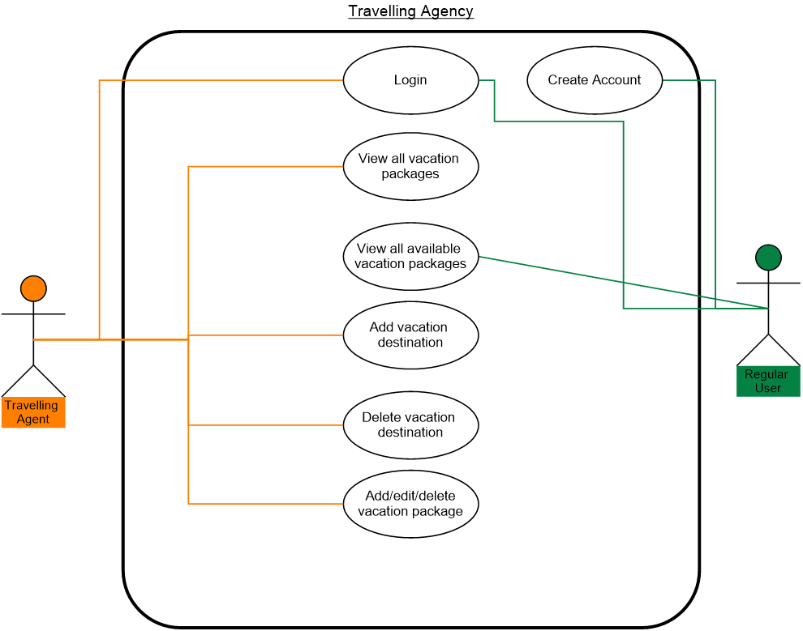

# Database Diagram

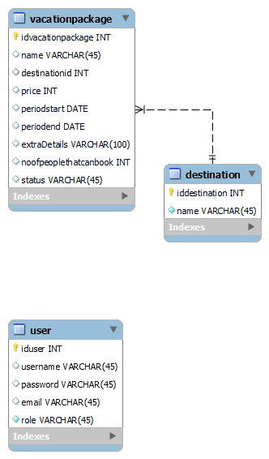

# Class Diagram

